Installation Instructions

for Guideline™Pipe Guides

Pipe guides are utilized to guide the piping (or tube) in an axial fashion during pipe (or tube) expansion and contraction caused by temperature change. The guide is not meant to carry the weight of the piping system. Traditional piping support methods are required to carry the weight of the pipe and the media within. The guide(s) protect the expansion joints and/or vital equipment against shearing forces by preventing lateral, or angular, pipe movement.

Pipe guides are manufactured with a two-piece spider and a two-piece housing. The guide is installed by bolting the two-piece spider around the pipe prior to insulating the pipe. (Note: in the case of dissimilar metals; isolation media is either wrapped around the pipe or placed between the outer surface of the pipe and the inner surfaces of the spider to reduce galvanic corrosion). Notice in the figure below that the spider is positioned within the housing approximately half the housing thickness for it’s neutral position.
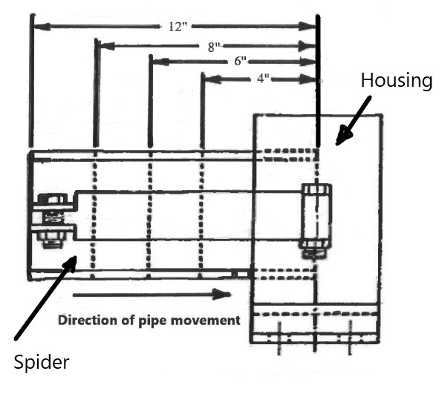

After the insulation is applied to the pipe, the bottom half of the two-piece body is bolted or welded to sufficient structure. The second half of the body is bolted into place completing the guide.

Typically, an internally pressurized expansion joint will have the first pipe guide at a distance of 4 pipe diameters on either side of the expansion joint and a second guide at 14 pipe diameters. Then intermediate guides are then spaced based on pipe size and line pressure. Typically, externally pressurized expansion joints have an internal guide ring that allows the first guide to be placed at 14 pipe diameters and then intermediate guide spacing beyond that. The chart on the following page is typical for intermediate guide spacing.

See the installation instructions for the specific expansion device to insure proper spacing of the initial guides.

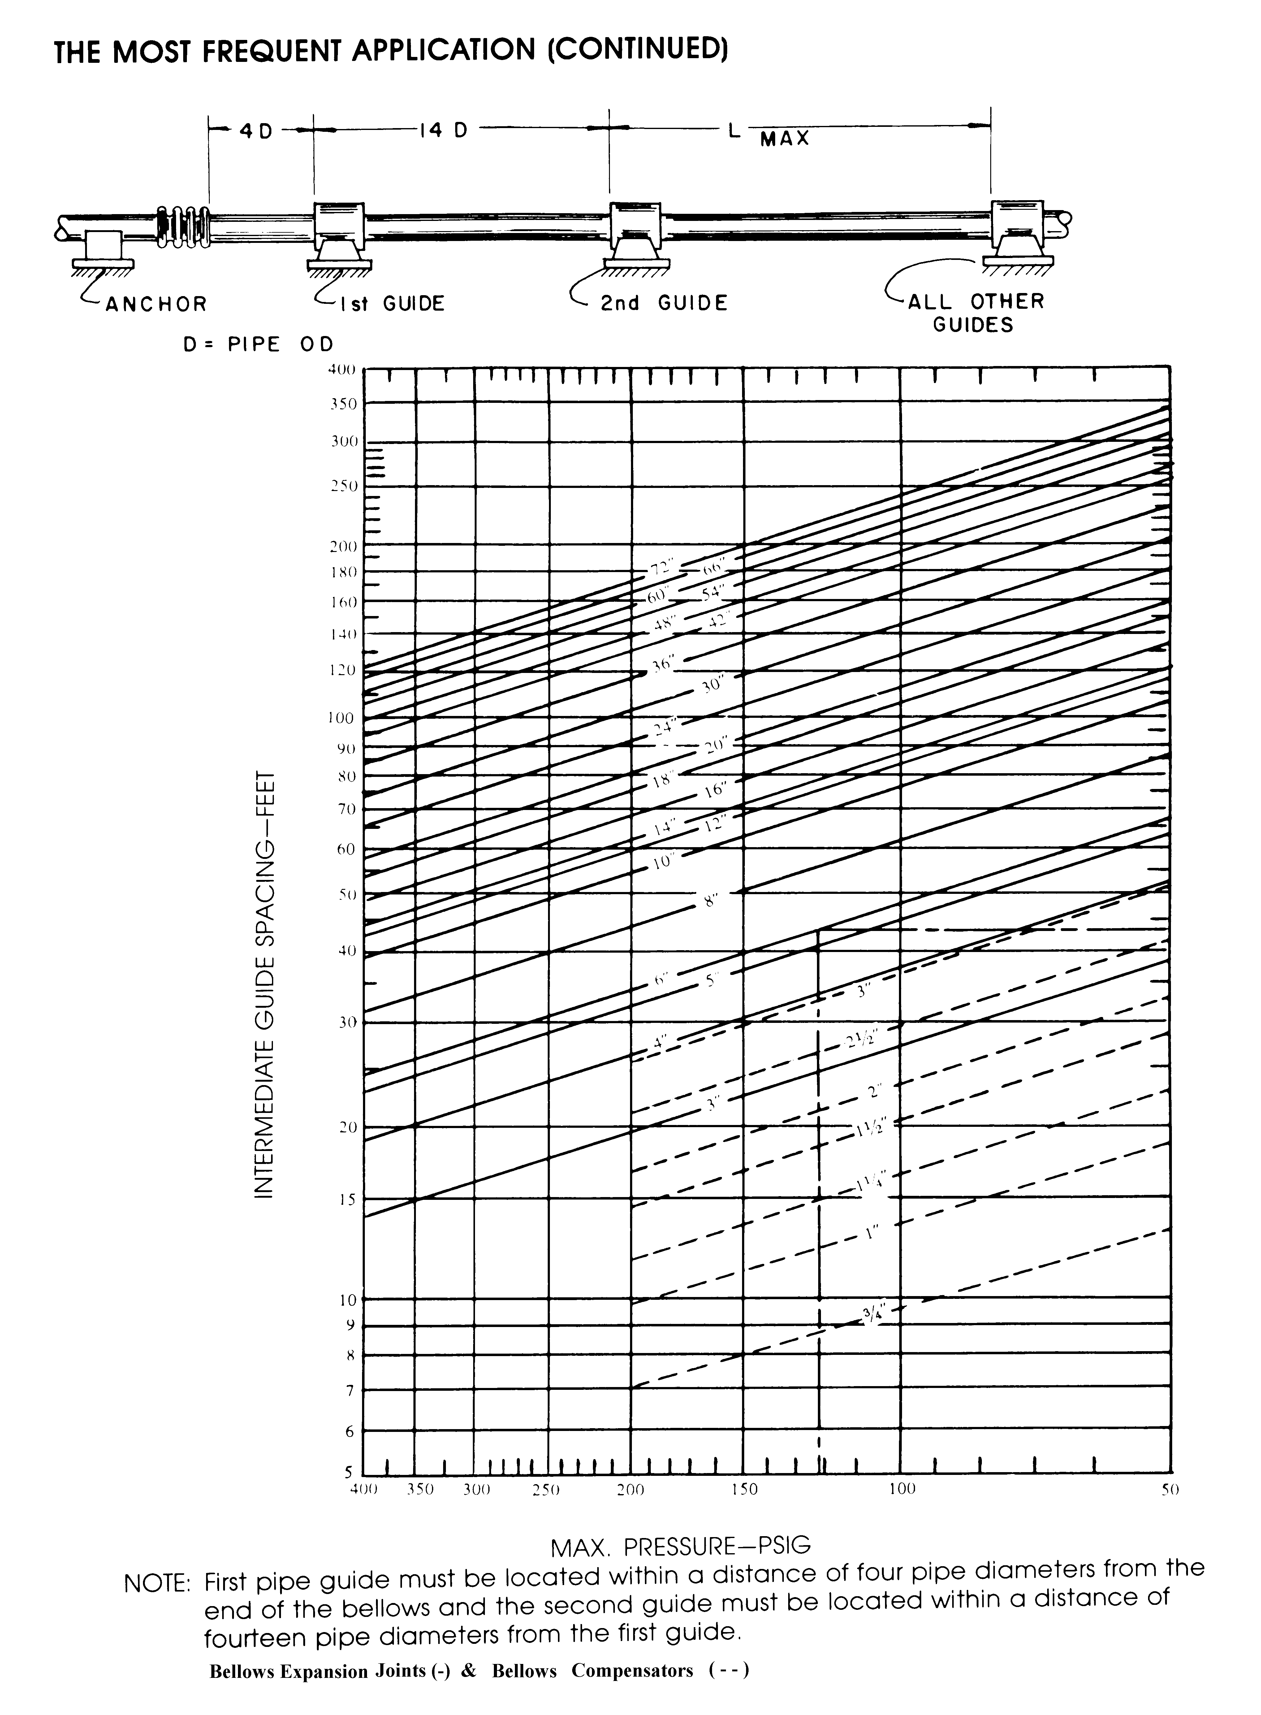
This chart is for steel pipe, contact factory for copper tube guide spacing.

